Birla Institute of Technology & Science - Pilani, Hyderabad Campus
Second Semester 2012-2013
CS F211 / IS F211: Data Structures & Algorithms
Test – 2 Date: 02.04.2013
Type: Closed Book Time: 60mins Marks: 60
All parts of the same question should be answered together.
1.a. Give an O(n log k)-time algorithm that merges k sorted lists with a total of n elements into one sorted list. Give two solutions to this problem, one without using heap and another by making use of heap. [3 + 5 Marks]
1.b. Draw the resulting Binary Search Tree after removing 17 from the below mentioned Binary Search Tree. [3 Marks]
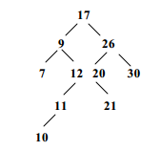
1.c. Determine the order in which the vertices of the following binary trees will be visted under (1)preorder and (2)post order traversal. [3 Marks]
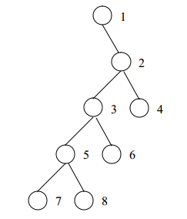
1.d. Specify a data structure that supports the following operations: [2 Marks]
insert(x,T) – Insert item x into the set T.
delete(k,T) – Delete the kth smallest element from T.
member(x,T) – Return true iff x ∈ T.
All operations must take O(log n) time (in worst case also) on an n-element set.
1.e.The following array A is a Min Heap: 2, 5, 9, 8, 10, 13, 12, 22, 50. [True /False] [+2 0 -1]

1.f. Assume the has function for String adds up the Unicode value for each character. [+2 0 -1]
public int hashcode(String s) {
int result = 0;
for(int i = 0; i < s.length(); i++)
result += s.charAt(i);
return result;
}
Hashcode for "DAB" and "BAD"?
A. 301, 103
B. 4, 4
C. 412, 214
D. 5, 5
E. 199, 199
Choose the correct answer from above options.

2.a. Consider a binary heap containing n numbers (the root stores the greatest number). You are given a positive integer k < n and a number x. You have to determine whether the kth largest element of the heap is greater than x or not. Your algorithm must take O(k) time. You may use O(k) extra storage. ` [8 Marks]
2.b. What is the minimum and maximum number of elements in a heap of height h? [4 Marks]
2.c. Prove that there are at most Ciel(n / 2^{h+1}) nodes of height h in an n element heap. [8 Marks]
3.a. Suppose we have a hash table with 2n slots with collisions resolved by chaining, and suppose that n/8 keys are inserted into the table. Assume each key is equally likely to be hashed into each slot (simple uniform hashing). What is the expected number of keys for each slot? Justify your answer. [10 Marks]
3.b. Design an algorithm that takes fewer than 2n - 3 comparisons to find the two smallest elements(first and second smallest elements) in an array of length n? Any algorithm that takes greater than or equal to 2n -3 comparisons will not be considered for evaluation. [10 Marks]

